1 XSLT 2

1.1 A 2

1.1.1 b5a_termin.xlst 2

1.1.2 b5a_termin.html 3

1.2 B 4

1.2.1 b5b_termin.xlst 4

1.2.2 b5b_termin.html 5

1.3 C 7

1.3.1 b5c_termin.xslt 7

1.3.2 b5_formatierung.xslt 8

1.3.3 b5c_termin.html 9

# XSLT

## A

### b5a_termin.xlst

<?xml version="1.0" encoding="UTF-8"?>

<xsl:stylesheet version="1.0" xmlns:xsl="http://www.w3.org/1999/XSL/Transform">

<xsl:output method="html" version="5.0" encoding="UTF-8" indent="yes"/>

<!-- Termin Template rendering -->

<!-- 1. Level (Parent: root node) -->

<!-- 1. Stage Entry point of traverse -->

<xsl:template match="Termin">

<html xmlns="http://www.w3.org/1999/xhtml">

<head>

<title>Termine</title>

</head>

<body>

<br/>

<table border="1">

<thead>

<tr>

<th>Beginn</th>

<th>Ende</th>

</tr>

</thead>

<tbody>

<tr>

<!-- Go to 2. Level -->

<xsl:apply-templates select="TerminInfos"/>

</tr>

</tbody>

</table>

<br/>

<span>Dauer: </span>

<xsl:value-of select="./TerminInfos/Dauer/text()"/> (<xsl:value-of select="./TerminInfos/Dauer/@einheit"/>)<br/>

<span>Verschiebbar: </span>

<xsl:value-of select="TerminInfos/@verschiebbar"/>

<br/>

<span>Serientermin: </span>

<xsl:value-of select="TerminInfos/@Serientermin"/>

<br/>

<br/>

<xsl:apply-templates select="TeilnehmerListe"/>

</body>

</html>

</xsl:template>

<!-- Beginn Template rendering -->

<!-- 3. Level (Parent: Termininfos) -->

<xsl:template match="Beginn">

<td>

<xsl:value-of select="Datum/@tag"/>-<xsl:value-of select="Datum/@monat"/>-<xsl:value-of select="Datum/@jahr"/> (<xsl:value-of select="Uhrzeit/@stunden"/>:<xsl:value-of select="Uhrzeit/@minuten"/>)

</td>

</xsl:template>

<!-- Ende Template rendering -->

<!-- 3. Level (Parent: Termininfos) -->

<xsl:template match="Ende">

<td>

<xsl:value-of select="Datum/@tag"/>-<xsl:value-of select="Datum/@monat"/>-<xsl:value-of select="Datum/@jahr"/> (<xsl:value-of select="Uhrzeit/@stunden"/>:<xsl:value-of select="Uhrzeit/@minuten"/>)

</td>

</xsl:template>

<!-- Nothing to do on Dauer -->

<!-- 3. Level (Parent: Termininfos) -->

<xsl:template match="Dauer"/>

<!-- Nothing to do on Beschreibung -->

<!-- 3. Level (Parent: TeilnehmerListe) -->

<xsl:template match="Beschreibung"/>

<!-- Teilnehmerliste Template rendering -->

<xsl:template match="TeilnehmerListe">

<table border="1">

<tbody>

<!-- Go to Person node on same level -->

<xsl:apply-templates select="Person"/>

</tbody>

</table>

</xsl:template>

<!-- Person Template rendering -->

<!-- 3. Level (Parent: TeilnehmerListe) -->

<xsl:template match="Person">

<tr>

<td>

<xsl:number/>

</td>

<td>

<xsl:value-of select="Nachname/text()"/>, <xsl:value-of select="Vorname/text()"/>

</td>

</tr>

</xsl:template>

</xsl:stylesheet>

### b5a_termin.html

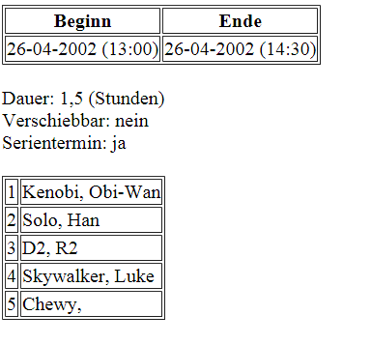

<!DOCTYPE html >

<html xmlns="http://www.w3.org/1999/xhtml">

<head>

<title>Termine</title>

</head>

<body>

<br/>

<table border="1">

<thead>

<tr>

<th>Beginn</th>

<th>Ende</th>

</tr>

</thead>

<tbody>

<tr>

<td xmlns="">26-04-2002 (13:00)

</td>

<td xmlns="">26-04-2002 (14:30)

</td>

</tr>

</tbody>

</table>

<br/>

<span>Dauer: </span>1,5 (Stunden)<br/><span>Verschiebbar: </span>nein<br/><span>Serientermin: </span>ja<br/><br/><table xmlns="" border="1">

<tbody>

<tr>

<td>1</td>

<td>Kenobi, Obi-Wan</td>

</tr>

<tr>

<td>2</td>

<td>Solo, Han</td>

</tr>

<tr>

<td>3</td>

<td>D2, R2</td>

</tr>

<tr>

<td>4</td>

<td>Skywalker, Luke</td>

</tr>

<tr>

<td>5</td>

<td>Chewy, </td>

</tr>

</tbody>

</table></body>

</html>

## B

### b5b_termin.xlst

<?xml version="1.0" encoding="UTF-8"?>

<xsl:stylesheet version="1.0" xmlns:xsl="http://www.w3.org/1999/XSL/Transform">

<xsl:output method="html" version="5.0" encoding="UTF-8" indent="yes"/>

<!-- Termin Templae rendering -->

<xsl:template match="Termin">

<html xmlns="http://www.w3.org/1999/xhtml">

<head>

<title>Termine</title>

</head>

<body>

<!-- Loop over each Person in Teilnehmerliste -->

<xsl:for-each select="TeilnehmerListe/Person">

<span>

<xsl:number/>.)

<xsl:value-of select="Nachname"/>,

<xsl:value-of select="Vorname"/>

</span>

<!-- Call related TerminInfos -->

<xsl:call-template name="termin_info_template"/>

<br/>

</xsl:for-each>

</body>

</html>

</xsl:template>

<!-- TerminInfos Template rendering -->

<xsl:template name="termin_info_template">

<table border="1">

<tbody>

<tr>

<th>Beginn</th>

<th>Ende</th>

</tr>

</tbody>

<tr>

<xsl:call-template name="begin_date_template"/>

<xsl:call-template name="end_date_template"/>

</tr>

<tr>

<xsl:call-template name="begin_time_template"/>

<xsl:call-template name="end_time_template"/>

</tr>

</table>

</xsl:template>

<!-- -Beginn Date Template rendering -->

<xsl:template name="begin_date_template">

<td>

<xsl:value-of select="//TerminInfos/Beginn/Datum/@tag"/>-

<xsl:value-of select="//TerminInfos/Beginn/Datum/@monat"/>-

<xsl:value-of select="//TerminInfos/Beginn/Datum/@jahr"/>

</td>

</xsl:template>

<!-- Ende Date Template rendering -->

<xsl:template name="end_date_template">

<td>

<xsl:value-of select="//TerminInfos/Ende/Datum/@tag"/>-

<xsl:value-of select="//TerminInfos/Ende/Datum/@monat"/>-

<xsl:value-of select="//TerminInfos/Ende/Datum/@jahr"/>

</td>

</xsl:template>

<!-- Beginn Time Template rendering -->

<xsl:template name="begin_time_template">

<td>

<xsl:value-of select="//TerminInfos/Beginn/Uhrzeit/@stunden"/>:

<xsl:value-of select="//TerminInfos/Beginn/Uhrzeit/@minuten"/>

</td>

</xsl:template>

<!-- Ende Time Template rendering -->

<xsl:template name="end_time_template">

<td>

<xsl:value-of select="//TerminInfos/Ende/Uhrzeit/@stunden"/>:

<xsl:value-of select="//TerminInfos/Ende/Uhrzeit/@minuten"/>

</td>

</xsl:template>

</xsl:stylesheet>

### b5b_termin.html

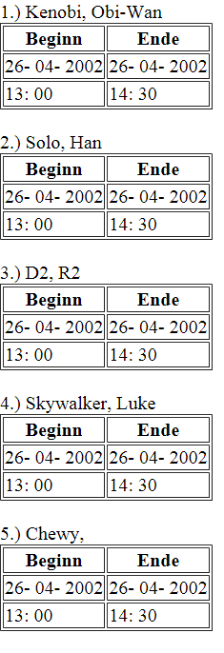

<!DOCTYPE html >

<html xmlns="http://www.w3.org/1999/xhtml">

<head>

<title>Termine</title>

</head>

<body>

<span>1.)

Kenobi,

Obi-Wan</span>

<table xmlns="" border="1">

<tbody>

<tr>

<th>Beginn</th>

<th>Ende</th>

</tr>

</tbody>

<tr>

<td>26-

04-

2002</td>

<td>26-

04-

2002</td>

</tr>

<tr>

<td>13:

00</td>

<td>14:

30</td>

</tr>

</table>

<br/>

<span>2.)

Solo,

Han</span>

<table xmlns="" border="1">

<tbody>

<tr>

<th>Beginn</th>

<th>Ende</th>

</tr>

</tbody>

<tr>

<td>26-

04-

2002</td>

<td>26-

04-

2002</td>

</tr>

<tr>

<td>13:

00</td>

<td>14:

30</td>

</tr>

</table>

<br/>

<span>3.)

D2,

R2</span>

<table xmlns="" border="1">

<tbody>

<tr>

<th>Beginn</th>

<th>Ende</th>

</tr>

</tbody>

<tr>

<td>26-

04-

2002</td>

<td>26-

04-

2002</td>

</tr>

<tr>

<td>13:

00</td>

<td>14:

30</td>

</tr>

</table>

<br/>

<span>4.)

Skywalker,

Luke</span>

<table xmlns="" border="1">

<tbody>

<tr>

<th>Beginn</th>

<th>Ende</th>

</tr>

</tbody>

<tr>

<td>26-

04-

2002</td>

<td>26-

04-

2002</td>

</tr>

<tr>

<td>13:

00</td>

<td>14:

30</td>

</tr>

</table>

<br/>

<span>5.)

Chewy,

</span>

<table xmlns="" border="1">

<tbody>

<tr>

<th>Beginn</th>

<th>Ende</th>

</tr>

</tbody>

<tr>

<td>26-

04-

2002</td>

<td>26-

04-

2002</td>

</tr>

<tr>

<td>13:

00</td>

<td>14:

30</td>

</tr>

</table>

<br/>

</body>

</html>

## C

### b5c_termin.xslt

<?xml version="1.0" encoding="UTF-8"?>

<xsl:stylesheet version="1.0" xmlns:xsl="http://www.w3.org/1999/XSL/Transform">

<xsl:output method="html" version="5.0" encoding="UTF-8" indent="yes"/>

<xsl:include href="b5_formatierung.xslt"/>

<!-- Termin Template rendering -->

<!-- 1. Level (Parent: root node) -->

<!-- 1. Stage Entry point of traverse -->

<xsl:template match="Termin">

<html xmlns="http://www.w3.org/1999/xhtml">

<head>

<title>Termine</title>

</head>

<body>

<br/>

<table border="1">

<thead>

<tr>

<th>Beginn</th>

<th>Ende</th>

</tr>

</thead>

<tbody>

<tr>

<!-- Call Beginn and Ende Templates -->

<xsl:call-template name="begin_template"/>

<xsl:call-template name="end_template"/>

</tr>

</tbody>

</table>

<br/>

<span>Dauer: </span>

<xsl:value-of select="./TerminInfos/Dauer/text()"/> (<xsl:value-of select="./TerminInfos/Dauer/@einheit"/>)<br/>

<span>Verschiebbar: </span>

<xsl:value-of select="TerminInfos/@verschiebbar"/>

<br/>

<span>Serientermin: </span>

<xsl:value-of select="TerminInfos/@Serientermin"/>

<br/>

<br/>

<table border="1">

<tbody>

<!-- Iterate over each Person and call corresponding template -->

<xsl:for-each select="TeilnehmerListe/Person">

<xsl:call-template name="person_template"/>

</xsl:for-each>

</tbody>

</table>

</body>

</html>

</xsl:template>

<!-- Beginn Template rendering -->

<xsl:template name="begin_template">

<td>

<xsl:value-of select="TerminInfos/Beginn/Datum/@tag"/>-<xsl:value-of select="TerminInfos/Beginn/Datum/@monat"/>-<xsl:value-of select="TerminInfos/Beginn/Datum/@jahr"/> (<xsl:value-of select="TerminInfos/Beginn/Uhrzeit/@stunden"/>:<xsl:value-of select="TerminInfos/Beginn/Uhrzeit/@minuten"/>)

</td>

</xsl:template>

<!-- Ende Template rendering -->

<xsl:template name="end_template">

<td>

<xsl:value-of select="TerminInfos/Ende/Datum/@tag"/>-<xsl:value-of select="TerminInfos/Ende/Datum/@monat"/>-<xsl:value-of select="TerminInfos/Ende/Datum/@jahr"/> (<xsl:value-of select="TerminInfos/Ende/Uhrzeit/@stunden"/>:<xsl:value-of select="TerminInfos/Ende/Uhrzeit/@minuten"/>)

</td>

</xsl:template>

<!-- Person Template rendering -->

<xsl:template name="person_template">

<tr>

<td>

</td>

<td>

<xsl:number/>

<xsl:value-of select="Nachname/text()"/>, <xsl:value-of select="Vorname/text()"/>

<xsl:if test="@id = //Termin/TerminInfos/@Terminersteller"> (is creator)</xsl:if>

<br/>

<xsl:call-template name="delimiter_template"/>

</td>

</tr>

</xsl:template>

</xsl:stylesheet>

### b5_formatierung.xslt

<?xml version="1.0" encoding="UTF-8"?>

<xsl:stylesheet version="1.0" xmlns:xsl="http://www.w3.org/1999/XSL/Transform">

<xsl:output method="xml" version="1.0" encoding="UTF-8" indent="yes"/>

<xsl:template name="delimiter_template">

<br/>

***********************************

<br/>

</xsl:template>

</xsl:stylesheet>

### b5c_termin.html

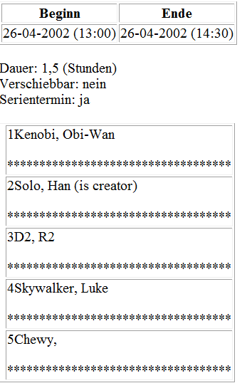

<?xml version="1.0" encoding="UTF-8"?>

<html xmlns="http://www.w3.org/1999/xhtml">

<head>

<title>Termine</title>

</head>

<body>

<br/>

<table border="1">

<thead>

<tr>

<th>Beginn</th>

<th>Ende</th>

</tr>

</thead>

<tbody>

<tr>

<td xmlns="">26-04-2002 (13:00)

</td>

<td xmlns="">26-04-2002 (14:30)

</td>

</tr>

</tbody>

</table>

<br/>

<span>Dauer: </span>1,5 (Stunden)<br/><span>Verschiebbar: </span>nein<br/><span>Serientermin: </span>ja<br/><br/><table border="1">

<tbody>

<tr xmlns="">

<td/>

<td>1Kenobi, Obi-Wan<br/><br/>

***********************************

<br/></td>

</tr>

<tr xmlns="">

<td/>

<td>2Solo, Han (is creator)<br/><br/>

***********************************

<br/></td>

</tr>

<tr xmlns="">

<td/>

<td>3D2, R2<br/><br/>

***********************************

<br/></td>

</tr>

<tr xmlns="">

<td/>

<td>4Skywalker, Luke<br/><br/>

***********************************

<br/></td>

</tr>

<tr xmlns="">

<td/>

<td>5Chewy, <br/><br/>

***********************************

<br/></td>

</tr>

</tbody>

</table></body>

</html>